In what ways does your media product use, develop or challenge forms and conventions of real media products?
Within this essay, I will be assessing the ways in which my film uses, develops or challenges forms and conventions of real media products. I will be doing so in terms of representation, genre, and narrative and media language.
In terms of genre, my film is a hybrid genre which illustrates conventions of both physical comedies and British social realist films. The first genre I will be exploring is physical comedy. Physical comedy is a form of comedy typically illustrated or conveyed by a pratfall, facial expressions and exaggerated movement and gestures. Generally actors within a film with the genre a physical comedy adopt clownish movement and expressions. Although customarily the language and dialogue within a typical physical comedy doesn't contain as much substance as other genres there may be a pun or a satirical comment thrown in at times.
For my film I looked specifically at silent movies. A silent film is a film with no synchronized recorded sound especially with no spoken dialogue. In silent films for entertainment the dialogue is portrayed through muted gestures, mime and the use of title cards. Typical conventions of a physical comedy also include credits at the beginning of the film. Most silent movies from the early 20th century are in black and white, for example Buster Keaton’s The General and the film I analysed, Charlie Chaplin’s Modern Times.
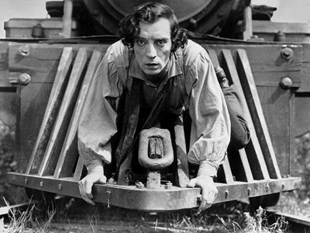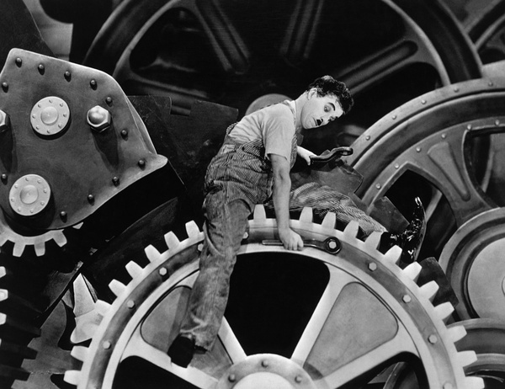
The pictures above illustrate the similarities between the two films. (The General by Buster Keaton and Modern Times by Charlie Chaplin)
Within my film, I have incorporated most of these conventions, for example, my film is in black and white, my actor’s movements are exaggerated and I have used title cards to illustrate the comedy within the film. An example of the use of title cards within my film would be during the scene where my three protagonists are on the wall of my main location (which is the back of a run-down council estate), smoking cigarettes, the title card reads “this rizzler is bad”, here I am incorporating the context of the film (for example following the story of gangsters) and the style of the film (physical comedy, in black and white) through the use of colloquial language and the title cards in general.
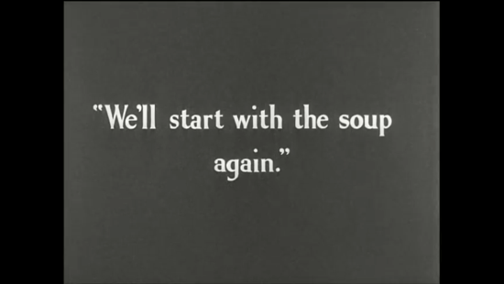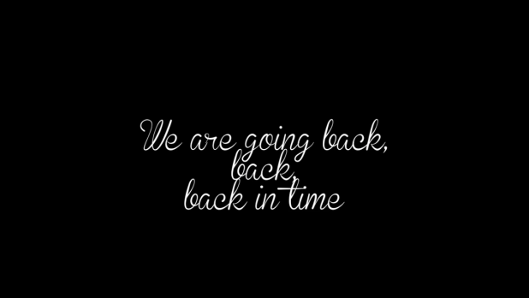
These images demonstrate the use of title cards within physical comedies. (“Modern times”- left, Oh crap! Here comes the po po!”- right)
This contrast between an old genre convention and a modern context creates comedy for the audience. An example of the actor’s movements within my film would be during the chase scene, within this, Ellie kicks and wiggles to try and get out of Jason’s grasp. The movements were not realistic because as previously discussed a typical convention of physical comedies is exaggerated movement.
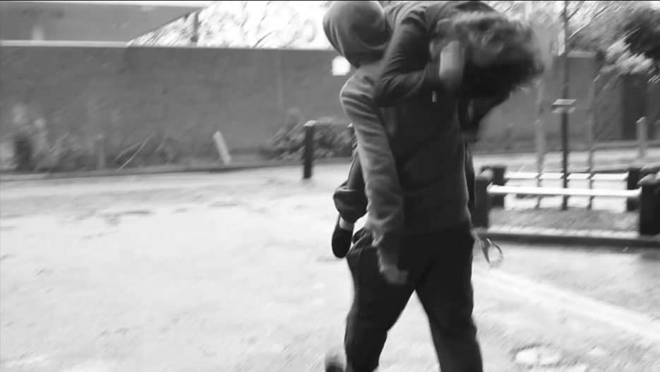
This image is a screen shot of the “chase scene” within my film.
My film communicates the genre of a physical comedy due to the use of title cards, exaggerated movement, silence and black and white desaturation on final cut. However, as previously discussed, my film is a hybrid genre and therefore uses certain elements of the other genre which is a British social realist, gangster film. However, the deviations within my film are mainly within the media language.
Media language consists of mise en scene, editing, cinematography and sound. Mise en scene can be defined as an arrangement of scenery and properties to represent the place where a play or movie is enacted. The typical conventions of a physical comedy in terms of mise en scene are that, the location reflects the back story of the protagonists, for example in Modern Times, the main locations were in and around the factory, this essentially represented the protagonist’s back story because “The Little Tramp” works in the factory. The factory, unlike any other factory of the times was simplistic and the machinery seemed larger than life. Not only does this create a theatrical element to the film, but it shows the construction of a reality rather than a reflection of one, as does most locations within physical comedic films. Similarly, I chose to film in the back of a run down council estate because it reflected the back story of my protagonists (three troubled teenagers attempting to be gangsters). However, my film deviates from this; because it is a British social realist film as well, the set was not built purposefully for this film and therefore was naturalistic and not theatrical.
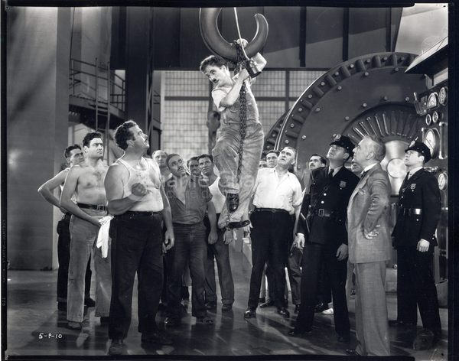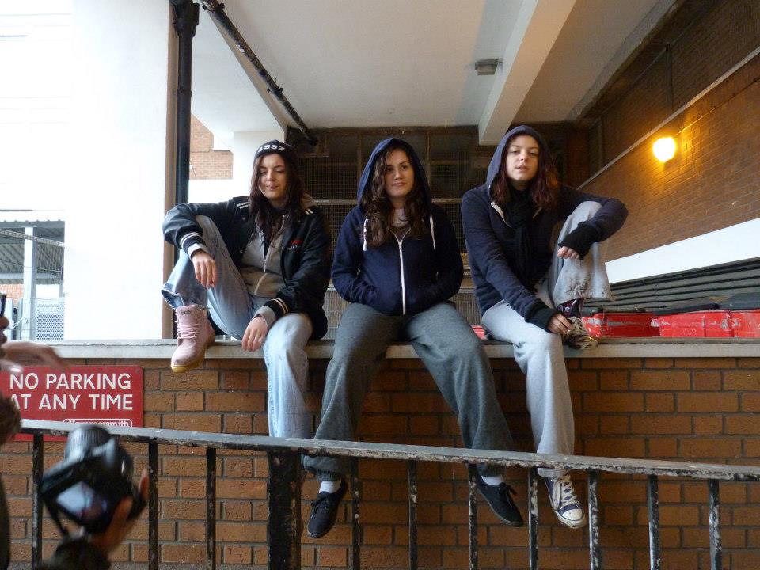
These images demonstrate how the locations reflect the back story of the protagonists.
In addition, the costumes within a physical comedy generally reflect the protagonist’s class or environment. Within Modern Times, the characters working in the factory wore typical work attire, for example overalls and grubby shirts. Within my film, the characters wore hooded jackets, track suit bottoms and trainers because I understood that attire to be the stereotypical outfit for a working class troublesome teenager. By incorporating costume which reflected the protagonists’ class and environment, I used the typical conventions of a physical comedy.
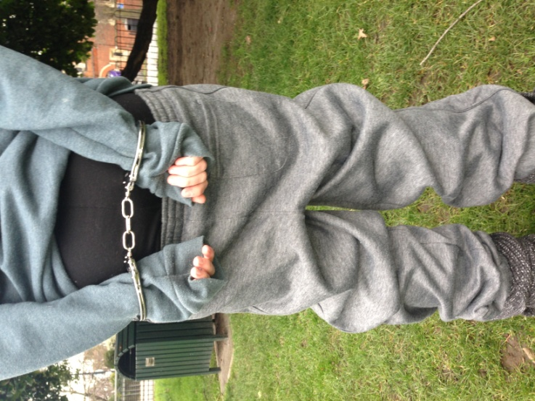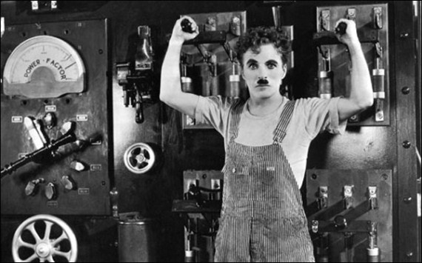
The images above show how the costumes reflect the environment and context of the film.
Furthermore, physical comedies are heavy lit, thus creating a theatrical sense to the film. For example, within Modern Times, Chaplin uses bright lights which could represent the lights within the location. The use of bright lighting became evident from the looming shadows of the factory equipment and machinery in the moving image. My film completely deviates from the lighting used in a physical comedy because I have used natural lighting throughout. I chose to do this because I am incorporating aspects of a British social realist film which uses natural lighting.
Lastly, the acting style within physical comedies as previously discussed is over exaggerated and there is a use of effective facial expressions. An example within Modern Times which clearly illustrates this is during what can be labelled the “Chase scene”. Within this scene, the protagonist chases those who are in a sense “above” him in terms of class. The movement here was exaggerated and clearly theatrical and therefore not realistic. Although, as I previously stated I used exaggerated movement within my film, most of it was naturalistic. For example during the scene where my protagonists are laughing at the phone calls they are receiving. Unlike a typical physical comedic film, my film reflects certain people within a society rather than constructing a reality. I did this because I am making a social commentary about how certain people within the youth of today behave.
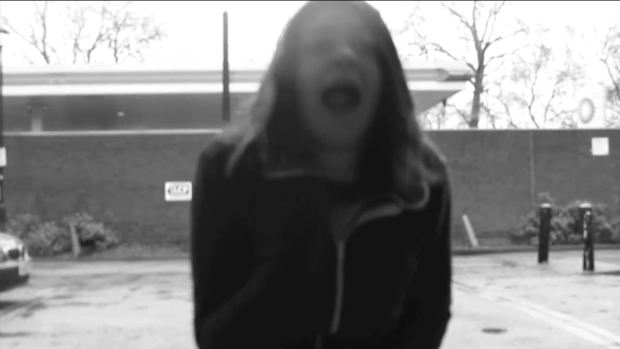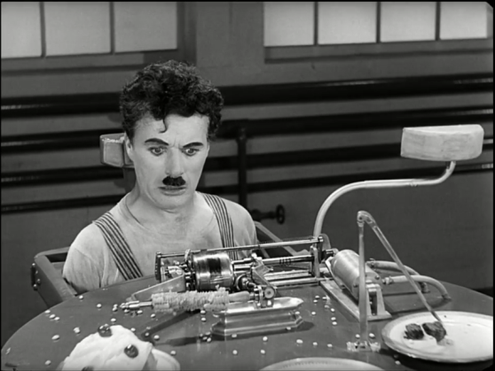
Here, I am demonstrating the similarities within the acting style in the two films.

The genre of a physical comedy typically uses close ups, which are used to enhance or to bring the comedic gestures to the audience's attention, and an establishing shot within certain extracts to set the scene and wide shots. The camera generally remains static in these films. The fact that the camera is still the whole way through the film creates a more theatrical element. For example, as the camera doesn't move to focus on one character, the actor's movements must be more exaggerated and theatrical. However, as demonstrated in the clip below there is a pan used to reveal Chaplin's character. By doing this, the audience see the typical factory worker and then they see Chaplin, who is a small, funny looking man and thus enhances the comedy. Within my film, I used close ups to transition from one scene to another; however the camera didn’t remain static throughout the film because, as I will describe below, I wanted to incorporate certain elements from the other genre as well.
Typically, within a physical comedy the editorial conventions are purely continuity editing. Continuity editing is mainly used for comedies because their target audience range to children because it makes the story easier to follow. An example of continuity editing within Modern Times is during the scene when Chaplin is used to try the machine. Within this clip there is a use of match on action. It is evident that this technique is used when Chaplin's boss places the screws on the table. The first shot is of the boss reaching to the table; it then cuts to what he has placed on there. By doing this, the editor is creating a comedic element within this scene. By cutting to a close up of the screws, the audience become aware that Chaplin is about to eat them. I also use continuity editing within my film purely for audience purposes. An example of continuity within my film would be during the scene where the first shot shows two of the characters laughing and getting caught by the police, this is all shot in a wide shot and it then cuts to an establishing shot where one of the protagonists runs away from the police.
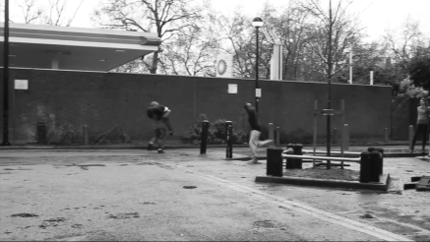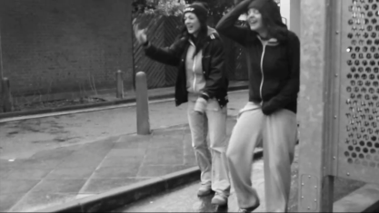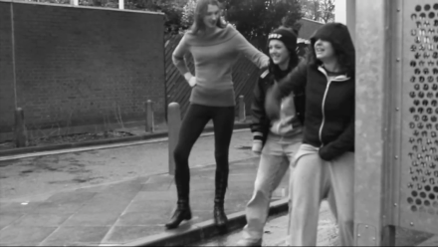
These images show the sequence of shots within my continuity editing.
In terms of representation, a physical comedic film has no deep meaning and is purely created for comedy, however Chaplin's film deviates from the typical representation, as the meaning of the whole film reflects the mood of the society, thus classifying it as a social comedy. The representation (of which essentially is a hegemonic structure) is portrayed through the use of command movements within the opposing identities. For example Chaplin's boss gestures to him that he needs to move faster, Chaplin does so and ends up in a frantic state. This is proving that the dominant ideology represses the inferior ideology till they have no control. This representation clearly comes from Chaplin as most of his films reflect juxtaposition between ideologies or classes, for example The Great Dictator. My film, similarly to Chaplin’s film however differently to a typical physical comedy represents the way certain groups of youth believe they are in control, however there is always someone above them which is the law. Unlike Chaplin’s film, this representation wasn’t illustrated through costume however it was through props and music. The prop which illustrated this was a pair of hand cuffs. During the entrance of the police men, I focused on the hand cuffs to show he has power. Also, he is the only male in the cast so however stereotypical, it portrays the strength of the law. In addition, the music at the end focuses on the lines “I’m locked up and they won’t let me out”. Although this was used for comedic affect it was also used as an ideological message and representation of the down fall narrative of these people’s lives.
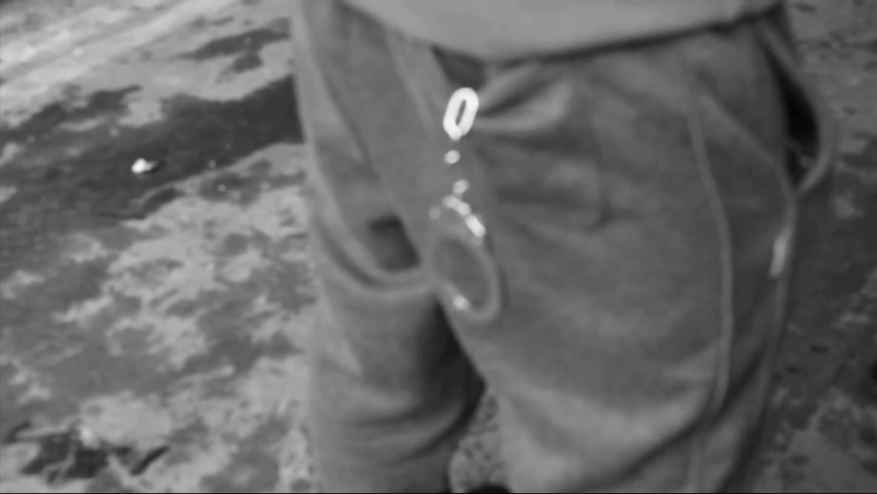
This image shows the close up of the hand cuffs within my film.
Typically in physically comedic films there is a use of binary opposition narrative (Levi-Strauss) because they generally reflect the state of the society. In Modern Times there is an absolute conformity because the whole film throughout reflects the introduction of modernity. The binary opposition within this film is between the dominant ideology and the proletariat. The film presents a clash between the classes. This is represented through the location (a factory) and the plot. Within the plot there is a binary opposition of the collapse of society due to the introduction of modernity and the comedy of Chaplin's movement. Similarly, “Oh crap here comes the po po!” presents a binary opposition between the inferior and dominant ideology.
As previously mentioned, my film is a hybrid genre, so as well as physical comedies I also researched British social realist/gangster films. In terms of genre conventions, the protagonist dislikes his low status in life and wants more, unlike other genres, the story takes place in a big city, and the gangster can only gain power by taking it. It is survival of the fittest, and the only law is the law of the jungle. The only loyalty the gangster feels is for his own friends and family, success is measured in material goods - flashy cars, expensive clothes, and mansions. Women are measures of success as well. The hero's antagonist is society, and the enforcers of the law. The police, the FBI, the CIA represent the enforcers of societal status quo. The end justifies the means- the benefits the protagonist gains justifies how he gets it. In addition, the protagonists are generally black men. Ill Manors conforms to the typical genre conventions demonstrated above. Take the example of the montage within the film. This montage reflects the life of a drug dealer from when he comes out of prison to when he becomes a millionaire. This demonstrates the first convention presented above. My film conforms to this because my actors are selling drugs for a living; therefore my film reflects the life of a drug dealer as well. Next, the film takes place in a large town (Forest Gate); this is presented through the mise en scene with large grey-bricked buildings and alley ways. My film is set in Shepherds Bush in the back of a run down estate, here; I am conforming to the conventions. Thirdly, the characters within the film kill in order to gain power and respect within the business. For example there is a scene where the young boy who wants to be accepted within the crowd has to go through a series of tasks as part of an initiation process to beat up his best friend and to kill a group of individuals. I challenge this within my film by involving no guns or knives in it I did this because I didn’t want my film to be a violent film.
Typically within British social realist films, the location consists of a run down council estate (which is used to reflect the class of the characters, however not the status of them), the location is also used to reflect the mood and atmosphere of the film, which is quite dark and dramatic, it could also be a reflection of the narrative because by the end of the film everything collapses. I have incorporated this into my film, for example my films location is in the back of a run down council estate. As my characters are working class, this location reflects their background.
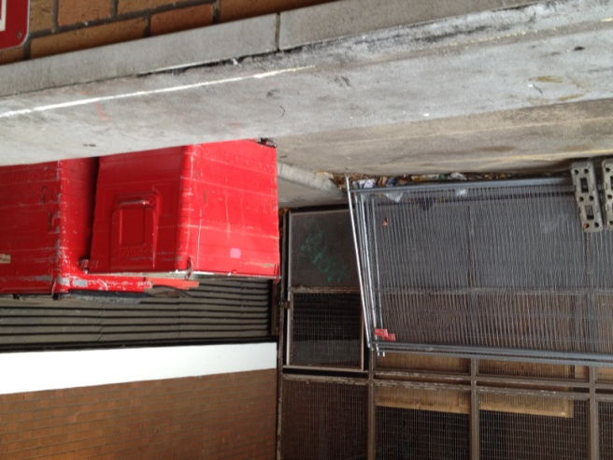
This image shows the location of my film.
The lighting within British social realist films is mainly natural lighting, however as a lot of the drug dealing is done secretly; there is a use of street lamps at night. Within this, there is an implicit meaning, the fact that this scene is set at night, it gives the film a dark atmosphere. In addition, the genre of the film is British social realist drama, and the fact that a lot of the film is shot at night creates the dramatic sense of the film, whereas the day light reflects the realism of the film. I challenge this convention because at no point is my film shot at night so there is natural day light used throughout. I decided to challenge this convention because I wanted to maintain the comedy in my film and I felt that shooting at night would add unnecessary drama to the film.

The costume typically reflects the stereotypical attire of someone who lives on a council estate, for example, hooded jackets and tracksuit bottoms. Once again the film Ill Manors conforms entirely to conventions of a British Social Realist film in terms of the costume. Furthermore, by looking at the characters costumes, the audience can immediately identify the class of the individuals. In addition, the film's target audience can relate to the costumes because it's everyday attire. As previously discussed, my film completely conforms to this.

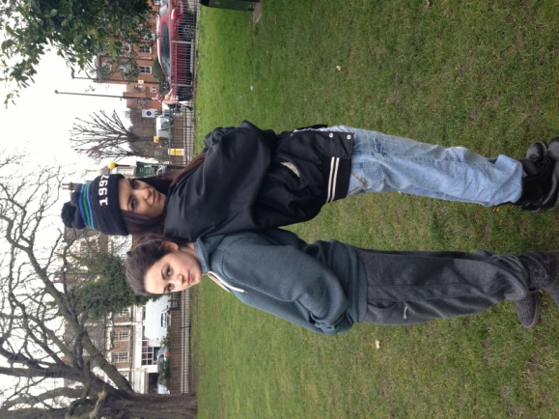
These images demonstrate the typical costume of British social realist/gangster film.

Typically the character movement or acting style of this genre consists of something mischievous. For example, in Ill manors during the scene where a woman is injecting herself with drugs, the woman’s facial expressions, body language etc show the effects the drugs are having on her. This reflects a downfall narrative. My film isn’t quite so dramatic, however my actors are doing something mischievous and illegal because they are selling drugs, therefore I conform to this convention. Typically, in this genre, the actors are predominantly black males. My film however challenges this because the cast is predominantly female and all white. I did this because I wanted have a complete juxtaposition of the stereotypes and make my film more light hearted because it is based around three middle class white girls who think they are “gangsters”, hence my tag line “so you think you’re a bad man? Well you have no idea.”

The acting style, unlike Modern Times is naturalistic; this is because Ill Manors is reflecting a reality that people of that class or in that situation can relate to. As previously discussed, Ill Manors is a British Social Realist, so the acting style impacts the commentary of the film. By this statement, I mean that Ill Manors comments on the life of young working class British individuals who are trapped in a cycle of drug dealing, the acting style then impacts this because it is naturalistic and therefore easy for people to relate to. My film is also naturalistic; however I’ve developed the naturalism within the film by adding some physical comedic elements and making my actor’s movements exaggerated and theatrical.

Typically within social realist films, there is a use of close ups for an emotional attachment to the characters, establishing shots to allow the audience to identify the surroundings of the film and wide shots and long takes during conversations. In addition, the camera tends to track a lot while following a specific character, and to show status, the angles vary depending on how great the character's status within the film is. I have incorporated all of these cinematographic elements in my film other than establishing shots. I decided against establishing shots because I didn’t necessarily want to allow the audience to see the location.

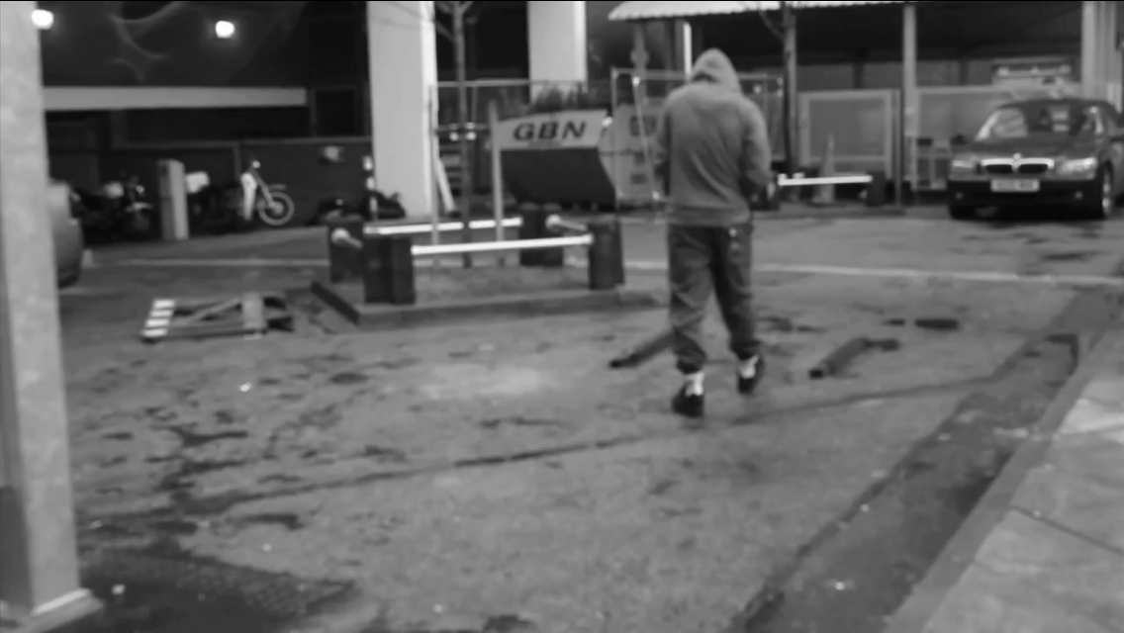
This image shows how I have incorporated tracking shots into my film.

Within physical comedies there are two different editorial conventions, one being continuity editing and the other montage editing. An example of montage editing within Ill Manors would be during the prisoner’s memory. Here, there is a montage of “video footage” of him as a child. In my film, I didn’t want to use Montage editing because I didn’t want to over dramatise the situation. My film is a comedy so I wanted the editing to reflect that.

Ill Manors and other social realist films reflect the reality. In other words, Ill Manors reflects the reality of working class drug dealers through different characters lives. Typically, within a social realist film, there is a representation of a hegemonic structure because it is reflecting society. In these particular films, society is represented as being structured with a dominant ideology, for example the government, and an inferior ideology for example the average citizen. Within this film, the hegemonic structure is put in place particularly. For example, the dominant ideology is the law and the inferior ideology is those who break the law or stereotypically break the law. In this instance the inferior ideology are working class drug dealers. Within my film, there is an obvious hegemonic structure between the police and the drug dealers. Although this isn’t reflected by costume because the police are undercover, I chose two tall actors to play police to show their status.

In terms of narrative, social realist films consist of a down fall. By this, I mean that the character’s story generally ends with death or jail. In Ill Manors all the drug dealers die except the protagonist who is seen to be troubled however throughout the film the audience begin to empathise with him. In my film I have incorporated a down fall narrative because my message is that at some point, the law will catch up with criminals. Although, unlike other British social realist films, there is no location which reflects this message for example a prison, I used close ups of hand-cuffs which represented these locations.

Overall, I have incorporated a lot of the conventions of my two genres, however because my film is a hybrid, I have conformed to one genre more than the other. It is clear that mainly the only conformity within my film in terms of a social realist film is the context and narrative whereas technically I have leaned more to the physical comedic conventions.

