How effective is the combination of your main product and ancillary text? 971 words
Within this essay I will be discussing how effective the combination of my main product and ancillary texts is. I will be discussing the ways in which my poster and film article communicate my film’s genre and whether this is effective or not.
In terms of my poster, I researched Charlie Chaplin’s Modern Times poster and Plan B’s Ill Manors poster as well as articles for the both of them. In order to poise my film poster between a silent comedy and gangster British social realist comedy, I implemented certain elements from both genres.
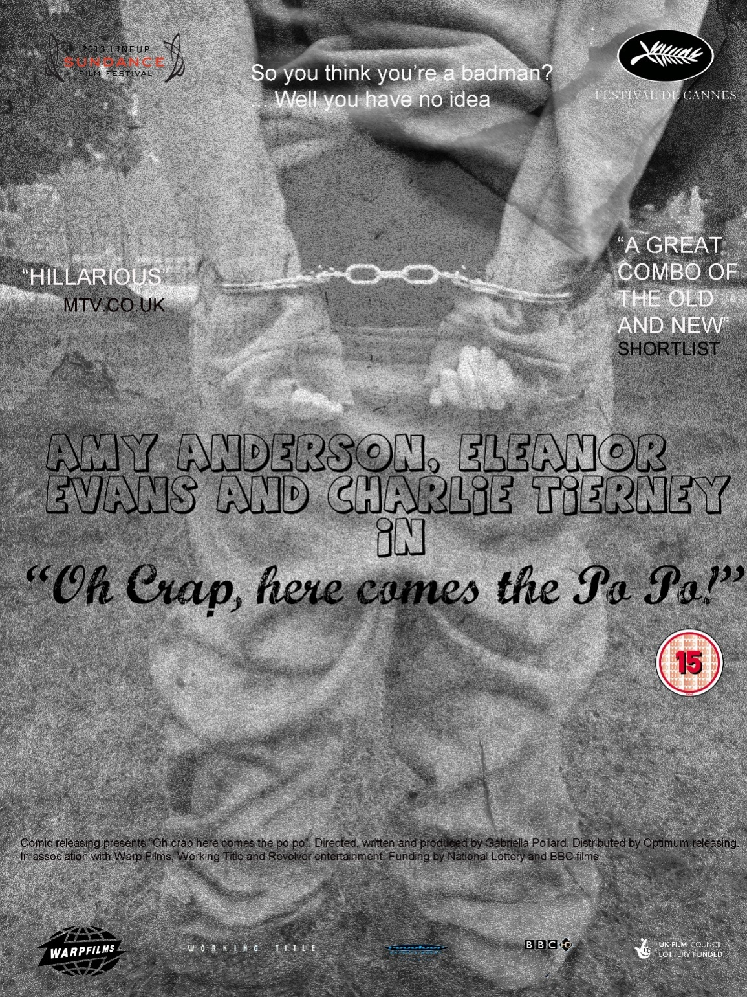
The use of working title, warp films, revolver entertainment and BBC HD appeals to a niche audience and the fact that it’s funded by the UK film council adds value to the film.
The 15 makes younger kids want to watch my film.
The tag line I used here reveals the comedic element of the film.
I used this font to make it easy to identify the fact that the film is an old film with a modern twist.
I used hand cuffs to signify a down fall narrative.
Here, I overlaid textured paper to give the poster and “old” effect. In addition, I did this to reveal the genre of a typical physical comedic film of the 20’s.
I used the font “…” and made the font size larger than the title to advertise the actresses more than the film. Similarly to Chaplin’s film posters.

This poster was intended for a more film literate audience. Preferably of age range around thirty. As I previously stated, there were certain linguistic and visual elements I incorporated in my film posters to attract particular audiences. Firstly, in terms of development of the poster above, I started with the idea of comically representing the way certain youths are portrayed as a collectivised identity. Here, I am portraying a collective identity, and therefore implying that this identity has been constructed by an outsider. The image that comically represents the youth is of my protagonist’s bottom, with their trousers half way down it. Next, I put the poster in black and white to reveal the hybrid genre of a physical comedy and a British social realist/ gangster film. In this particular poster I manipulated the linguistics in terms of font size and style, by isolating my characters names in a bubble font, which I used to represent the comedic aspect of my film and old fashioned “handwriting” font to represent the “Chaplinesque” element of the film. In addition I overlaid old textured paper on the original image which was also used to reveal the physical comedic side to my film and give it a 20’s feel. Typically on Chaplin and other film posters of the 20’s there is no certificate visible, however I wanted the poster to have a modern feel to it and to have some attributes of the posters of today. I would distribute my posters in places like free newspapers, for example the Evening Standard and the Metro, TIME OUT magazine and gyms. I have chosen these places because I would want to advertise my film in areas which are convenient for people to see.

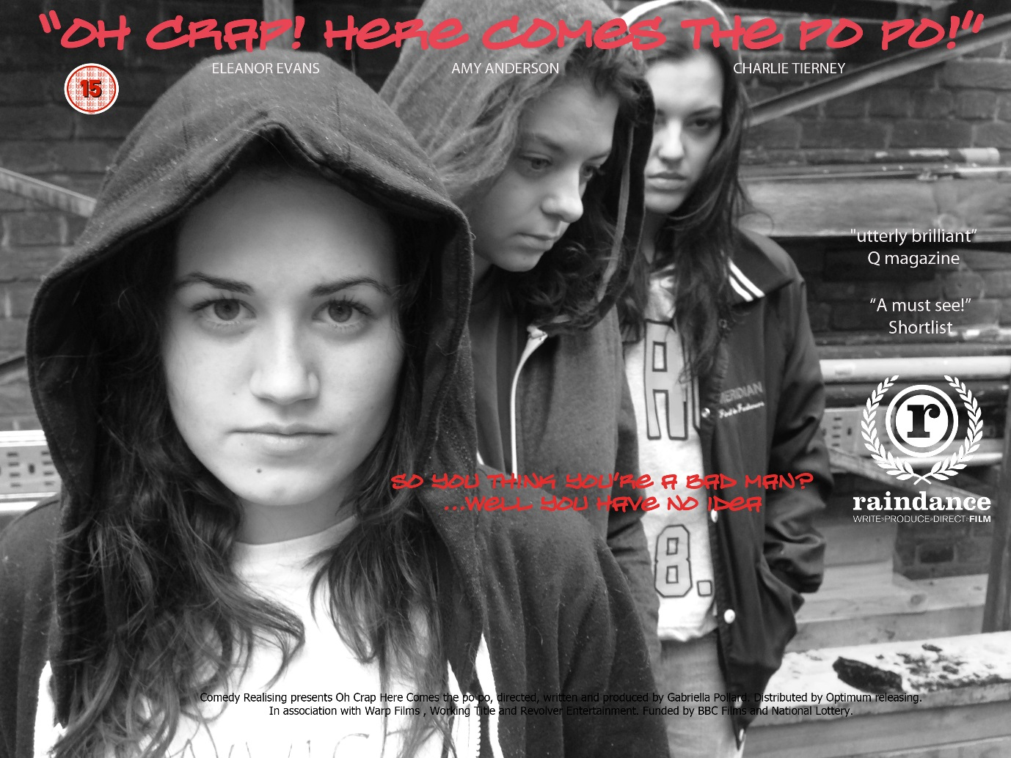
The use of the rain dance symbol was used to appeal to a more niche audience rather than a main stream audience.
The fact that my poster is in black and white communicates the fact that the film is in black and white and therefore has similar attributes to films of the 20’s.
I chose red font for my title and tag line because I wanted to appeal to a male dominated audience.
However, the fact that the characters are female would hopefully attract a female audience as well.
My characters are wearing hooded jackets because this is a stereotype associated with working class teenagers.
I chose graffiti font to signify teen vandals.

The poster above was intended for a teenage audience. The teenage audience I have chosen is older than 15. I chose this age range because I feel this audience would be more inclined to watch a silent black and white film. However, some children under the age of 15 will also be inclined to watch the film because they know they are not allowed to. As I previously stated, there were certain linguistic and visual elements I incorporated in my film posters to attract particular audiences. Firstly, in terms of development of the poster above, I started with the idea of representing tough youths from a working class background; however this predicate has been juxtaposed with the fact that the youths are female. Here, I am portraying the collective identity of “troubled” youths through females. In addition, like other modern film posters, my protagonists are centred and at least one of them is looking into the camera. I did this to communicate some form of intimidation coming from the individuals within the film.
Next, I put the poster in black and white to reveal the hybrid genre of a physical comedy and a British social realist/ gangster film. In this particular poster I manipulated the linguistics in terms of font size and style, by placing the title into a graffiti font and in a red colour. The intended connotations of this are the graffiti represents vandals and would communicate to my audience that the film is about gangsters or trouble makers and the red represents blood or anger in addition it stands out from the black and white. Lastly, the location I chose for my poster seems to be run down and a “no go” area, this would show the location of the film as well as implying the background of the protagonists. I would distribute my posters in places such as youth centres, tubes and bus stops.
In addition, my film’s message is that although gangsters may seem hard on the outside, the law will always have the upper hand. I chose to show this in a comic way because I felt that the best way for people to listen to your message is to make them laugh. In order to express this message, I firstly made my actors females because females are generally represented as the “weaker” gender and therefore I wanted to represent the weakness of the gangsters through the gender. In addition, gangsters are generally played by black actors, I chose white actors to deviate from the stereotype. Furthermore, the comedic aspect of my film was to be a physical comedy so I decided my characters should have exaggerated movement and facial expressions to express that genre. I also put my film in black and white, made it silent and used music from the 20’s to further develop the genre.
Lastly, my article reviews my film as a hilarious innovative film which combines two competely different genres. I chose to make my film article in the style of Empire because it is a comedic film about gangsters that is targeted to the teenage audience as is Empire. Furthermore I incorporated certain elements of the article to clearly demonstrate the magazine I chose. However, I decided to change the colour of the typical comedy film review in Empire because it is yellow and that didn’t show up on the page.

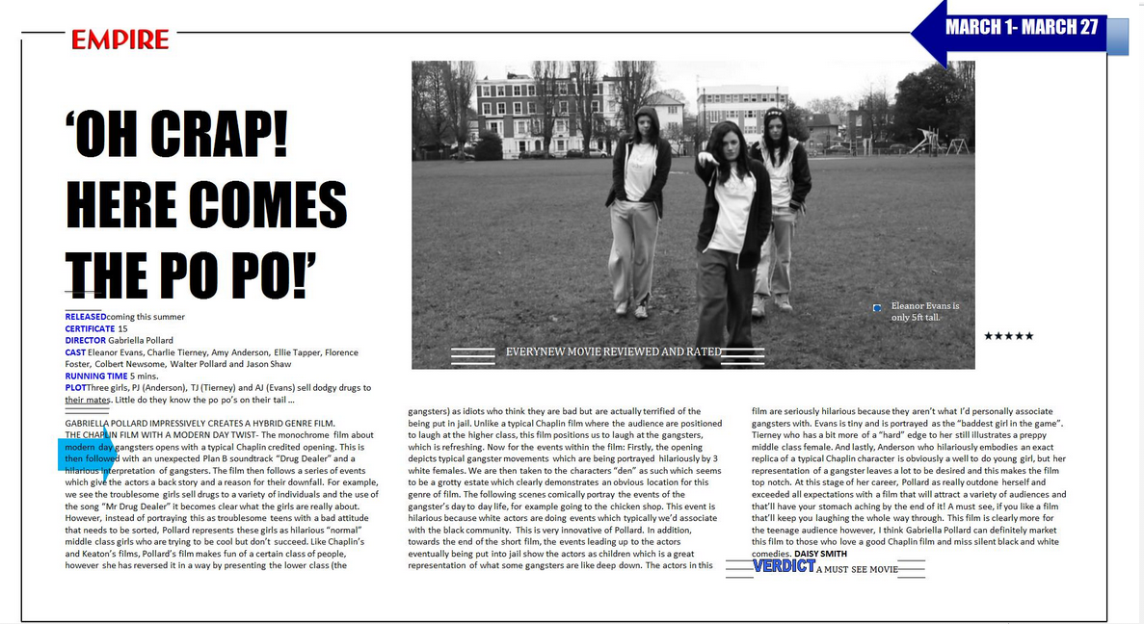
Star rating
Fact file
Fun fact.
Empire logo
Large font title
The article format is columns placed under and around the picture.

