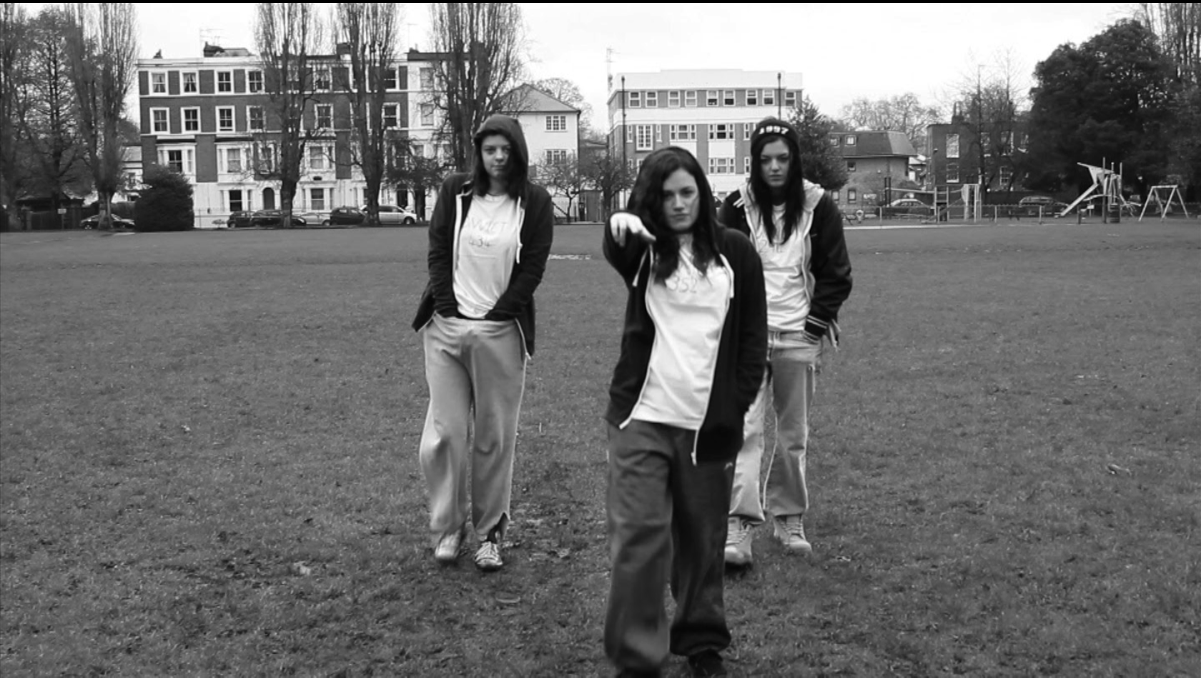
MARCH 1- MARCH 27
‘OH CRAP! HERE COMES THE PO PO!’
Eleanor Evans is only 5ft tall.

RELEASEDcoming this summer
CERTIFICATE 15
DIRECTOR Gabriella Pollard
EVERYNEW MOVIE REVIEWED AND RATED
CAST Eleanor Evans, Charlie Tierney, Amy Anderson, Ellie Tapper, Florence Foster, Colbert Newsome, Walter Pollard and Jason Shaw
RUNNING TIME 5 mins.
PLOTThree girls, PJ (Anderson), TJ (Tierney) and AJ (Evans) sell dodgy drugs to their mates. Little do they know the po po’s on their tail …

GABRIELLA POLLARD IMPRESSIVELY CREATES A HYBRID GENRE FILM.
THE CHAPLIN FILM WITH A MODERN DAY TWIST- The monochrome film about modern day gangsters opens with a typical Chaplin credited opening. This is then followed with an unexpected Plan B soundtrack “Drug Dealer” and a hilarious interpretation of gangsters. The film then follows a series of events which give the actors a back story and a reason for their downfall. For example, we see the troublesome girls sell drugs to a variety of individuals and the use of the song “Mr Drug Dealer” it becomes clear what the girls are really about. However, instead of portraying this as troublesome teens with a bad attitude that needs to be sorted, Pollard represents these girls as hilarious “normal” middle class girls who are trying to be cool but don’t succeed. Like Chaplin’s and Keaton’s films, Pollard’s film makes fun of a certain class of people, however she has reversed it in a way by presenting the lower class (the gangsters) as idiots who think they are bad but are actually terrified of the being put in jail. Unlike a typical Chaplin film where the audience are positioned to laugh at the higher class, this film positions us to laugh at the gangsters, which is refreshing. Now for the events within the film: Firstly, the opening depicts typical gangster movements which are being portrayed hilariously by 3 white females. We are then taken to the characters “den” as such which seems to be a grotty estate which clearly demonstrates an obvious location for this genre of film. The following scenes comically portray the events of the gangster’s day to day life, for example going to the chicken shop. This event is hilarious because white actors are doing events which typically we’d associate with the black community. This is very innovative of Pollard. In addition, towards the end of the short film, the events leading up to the actors eventually being put into jail show the actors as children which is a great representation of what some gangsters are like deep down. The actors in this film are seriously hilarious because they aren’t what I’d personally associate gangsters with. Evans is tiny and is portrayed as the “baddest girl in the game”. Tierney who has a bit more of a “hard” edge to her still illustrates a preppy middle class female. And lastly, Anderson who hilariously embodies an exact replica of a typical Chaplin character is obviously a well to do young girl, but her representation of a gangster leaves a lot to be desired and this makes the film top notch. At this stage of her career, Pollard as really outdone herself and exceeded all expectations with a film that will attract a variety of audiences and that’ll have your stomach aching by the end of it! A must see, if you like a film that’ll keep you laughing the whole way through. This film is clearly more for the teenage audience however, I think Gabriella Pollard can definitely market this film to those who love a good Chaplin film and miss silent black and white comedies. DAISY SMITH
A MUST SEE MOVIE

